STALLIoN SPIRIT YARD SIGNS
Show your school spirit with a Sjhhs spirit yard sign
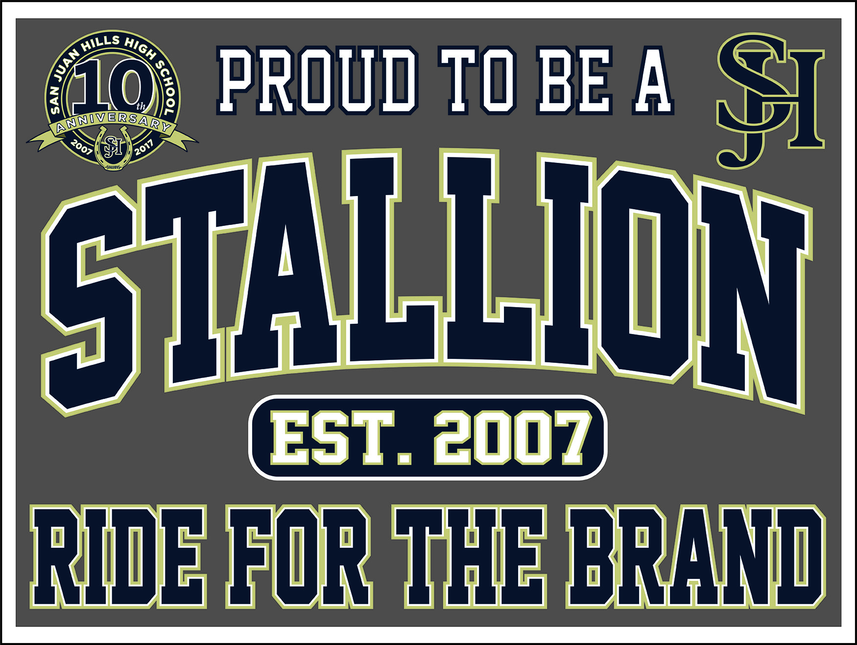
Football, baseball, basketball, golf, tennis, water polo, volleyball, lacrosse, cheer, band, Choral music, dance, theater arts, orchestra…..or just show your stallion spirit!!!

You customize your sign with your students name, sport, event, player #...etc
Only $18 without Name
or
Only $23 w/ custom name

Vinyl Yard Sign features:
- Free personalization!
- Durable weather resistant coroplast
- Yard sign is single sided.
- Measures 18 inches high x 24 inches wide.
- Includes metal stake.
- Assembly required.

Name_______________________________________ EMAIL__________________________________________

Sign design________________________________ Cell #____________________________________

Name on sign_______________________________ Player #_________________________________________

ORDER DEADLINE IS AUGUST 30TH!
Please Return order and payment to front office by 8/30/19

CK#_______________ Cash_________________ PayPal/cc (+1.00 fee)_______________________

Please make checks payable to: sjhhs ptsa

Questions: Debbie Bursey / sjhhsptsa@gmail.com*not printed at cusd expense*
